# Garlic Mustard has invaded the Upper Valley – Have you seen it in Thetford?

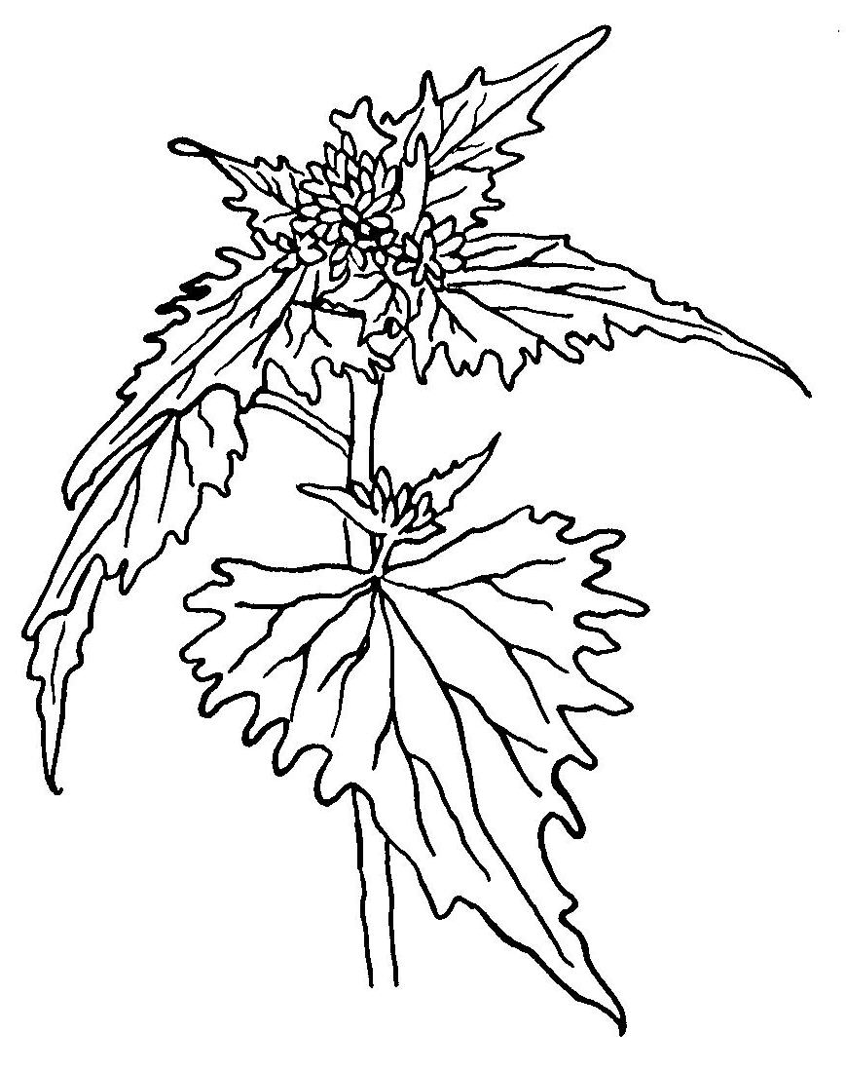

Garlic mustard is an aggressive competitor that crowds out native species and is endangering our native wildflowers. It grows fast, produces many seeds, and has no native predators (insect or disease). Once established, this plant dominates the understory of our NH and VT forests.

Fortunately, it is possible to control this plant with neighborhood effort and frequent monitoring. Through education and prompt action NH and VT woodlands can be protected.

**A few facts about the plant:**

·       Leaves and stems smell like garlic when crushed.

·       It is a biennial:

·       **first year plants** form a low rosette (like a dandelion) - leaves are rounded.

·       **second year plants** grow tall, form flowers and make seeds. Leaves are *deeply toothed and heart-shaped*.

·       Second year plants may reach 3’ in height, or more.

·       White flowers with four petals. Flowers in clusters at top of the stalk.   Blooms in spring (May).

·       Tolerates shade, can invade woodlands, and dominate the herb layer.

·       Tap root is white, with “S” curve near the top of the root.

·       Seeds ripen in long slender pods, average 100/plant (but can exceed1000s); seeds are mature by late July or August.

·       Seeds can remain viable for more than six years in the ground.

       ·       The plant is allelopathic, possessing a chemical that reduces regeneration of trees.

**What can you do?**

**CONTROL STRATEGY FOR GARLIC MUSTARD**

* **Plan to do the work in mid-May** prior to when the plant is likely to be flowering and easily seen; also seeds will not be mature at this time for escape.
* **Concentrate on the second year plants** as not all of the first year plants will survive.
* **Pull out entire plant** including root if possible.
* **Dispose of plants in plastic bags** and take to landfill as plants left on ground may sprout.
* **Start pulling at the outer edges of the colony** and begin to push back to the colony’s core. Look for single plant outliers and satellite populations, and remove before they go to seed.
* **Plan to return on annual basis**, as some seeds can last 5 years or more. There should be some sign of decline after 3 years of control.
* **Be vigilant at disturbed sites**. Garlic mustard is opportunistic, often arriving on equipment or in hay used on construction sites or road work.
* **For large infestations**, herbicides work best if applied on a warm day in late fall after a hard frost, or early spring before other plants have emerged (garlic mustard overwinters) -that way there will be less collateral damage to native plants nearby. A 2% solution of Roundup (glyphosate) has proved effective. Not recommended if there are desirable plant species in quantity nearby. **Herbicide work is prohibited near water; professional help is needed there.**

**For local assistance with identification or control contact:**

Li Shen, Thetford Conservation Commission [lilian.shen@dartmouth.edu](mailto:lilian.shen@dartmouth.edu) 785-4950

**Garlic Mustard References**

**For more background information on this plant:**

* An excellent 13-minute video about the plant: <http://vimeo.com/2855779>
* USDA fact sheet, with lots of links to videos, research articles, state websites:

<http://www.invasivespeciesinfo.gov/plants/garlicmustard.shtml>

* NH Guide to Upland Invasive Plant Species: <http://www.agriculture.nh.gov/divisions/plant_industry/invasive-species.htm>
* National Park Service overview: <http://www.nps.gov/plants/alien/pubs/midatlantic/alpe.htm>
* NJ data on population dynamics: <http://www.state.nj.us/agriculture/divisions/pi/pdf/garlicmustard.pdf>
* Comprehensive website at University of Michigan on the population dynamics and control options for garlic mustard: <http://www.ipm.msu.edu/invasive_species/garlic_mustard>
* NY Invasive Species Council, garlic mustard impacts, <http://www.nyis.info/index.php?action=invasive_detail&id=25>

**Bio-control research** seems to be closing in on a few insects:

* Evaluation of the potential of bio-controls for Garlic Mustard: <http://www.nyis.info/user_uploads/files/Evans%20MSU%202005.pdf>
* Powerpoint that outlines possible control agents, and bio-control review process: <http://www.mipn.org/Annual%20Meeting%2007%20presentations/natareaconf07.pdf>

**Effect of Garlic Mustard on forests**:

The plant seems to suppress the growth of native tree seedlings, by disrupting associations between native canopy tree seedlings and subterranean mycorrhizal fungi. It affects both hardwoods and softwoods. See:

* *Invasive Plant Suppresses the Growth of Native Tree Seedlings by Disrupting Belowground Mutualisms* by Kristina Stinson et al.(2006) This article summarizes how seedlings of certain hardwood species have reduced success when growing in a forest with garlic mustard. <http://www.ncbi.nlm.nih.gov/pmc/articles/PMC1440938/>

*The Invasive Plant Alliaria Petiolata (garlic mustard) Inhibits Ectomycorrhizal Fungi in its Introduced Range* by BD Wolfe et al (2008), pertaining to softwood trees seedlings. The page has an abstract of the article and you can download entire 7-page article: <http://onlinelibrary.wiley.com/doi/10.1111/j.1365-2745.2008.01389.x/abstract>

Updated: 5/2013